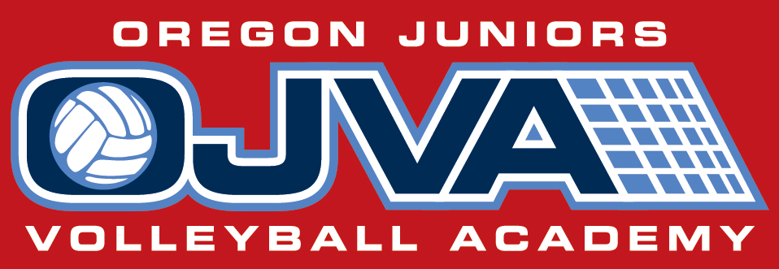
Present
Elite Volleyball Training session
2016
For top level 14u, 16u, 18u
and Varsity HS players
Coaches/ Instructor
Steve Suttich
Steve has been playing and coaching Volleyball for over 30 years. Steve has won both NCAA and USAV National Championships. Steve has been named All- American 7 times while playing in NCAA and USAV Championships. Steve is a 3 time MVP at USAV National Championships. He has coached at the HS (both boys and girls), Collegiate (Univ. of Washington), National and International levels. Steve has been the keynote speaker at National and International coaches clinics and has worked with former Men’s and Women’s USA National team coaches. Steve is currently the Director and Coach of Oregon Juniors Volleyball Acad.
Every OJVA Senior for the last 6 years has gone on to play college Volleyball. All Americans, All Conference, Team and Conference MVP’s…. D-1, D-2, D-3, NAIA. Many of these players will be helping coach at these sessions.
Sample Schedule
2:00p-2:30 Warm up time and Review
2:30p-2:45 Position Specific Movements
2:45p-3:45 Position Specific Skills Training
3:45p-3:55 Break and Video session
3:55p-4:30 Position Specific Skills Training

To Register use the links below
Setter Elite Session
Middle Hitting Session Outside Hitting Session
Setting For Setters July 11th-14th
Setters and Right- side players (Max of 18 Players)
- Preparation footwork to setting
- Transition Footwork
- Sets 1’s, 3’s, Slides, X’s, 4’s, B1’s, Bic
- Setting tight passes, Dumping
- Setters decisions processes
- Ball out of Net skills
Offensive Skills July 18th-21st
Middle Hitters (Max of 12 Players)
- Serve Recieve to hitting
- Transition footwork
- Hitting- 1’s, 3’s,
- Slides, B1’s, slides
- Blocking
- Out of system setting

Outside Hitters (Max of 12 Players)
- Serve Recieve to hitting
- Transition footwork
- Hitting- 4’s, X’s, 5’s, BIC
- High Flat, Chip, Wipe Off, Dink
- Blocking movements
- Out of system Setting
Session Fees
$150.00 Before June 25th
$175 After June 25th

The Courts in Beaverton
Is the premier Volleyball facility in Portland. The Courts is the most dedicated VOLLEYBALL facility in Oregon. We have 6 high quality hardwood courts with netting dividing each, Fully Air Conditioned, 43 ft high roof. We have over 200 training balls, 13 ball carts, 2 Ball Serving machines, 2 Passing Targets, 3 Setters Eye Targets, Video equipment and Monitors, jump training equipment, spiking, Hitting, defensive and setting training tools. All of this along with the best coaches to direct and train you as the Elite Player you want to become. The Courts is
“The Volleyball Facility”
The Courts has and continues to play host to USA Volleyball Youth, Junior and Adult events, Jr High and High School events and even the USA Men's National Volleyball Team.
The Courts in Beaverton
14523 SW Millikan Way #110
Beaverton , OR 97005 Phone: 503-646-7905
http://www.thecourtsinbeaverton.com/ SummerCamps.html

